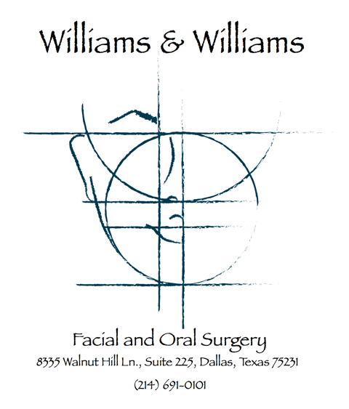

Patient Name: ________________________________________________________________________
Appointment Date: __________________________________
Appointment Time: __________________________________

Before I.V. Anesthesia Sedation:
- You may NOT have anything to eat or drink (including water) for six (6) hours prior to the appointment.
- No smoking at least twelve (12) hours before surgery. Ideally, cut down or stop smoking as soon as possible prior to the day of surgery.
- A responsible adult must accompany the patient to the office, remain in the office during the procedure and drive the patient home.
- The patient should not drive a vehicle or operate any machinery for 24 hours following the anesthesia experience.
- Please wear short sleeved shirts or loose fitting clothing with sleeves. Preferably no dresses or heels.
- Contact lenses, jewelry and dentures must be removed at the time of surgery.
- Do not wear lipstick, excessive makeup or nail polish on the day of surgery.
- No personal items (purses, cell phones, etc) will be allowed in treatment rooms.
- If you have an illness such as a cold, sore throat, stomach or bowel upset, please notify the office.
- If you take routine daily medications, please check with the oral surgeon prior to your surgical date for instructions.

_____________________________________________________________________________________
Patient Signature or Legal Guardian Date

